**IST370**

**Lab 6 (28 points)**

**Joining Tables Using Both Implicit and Explicit Join Methods**

**Your Name: Alexa Schnetzler**

**Teammate 1: ________________**

**Teammate 2: ________________**

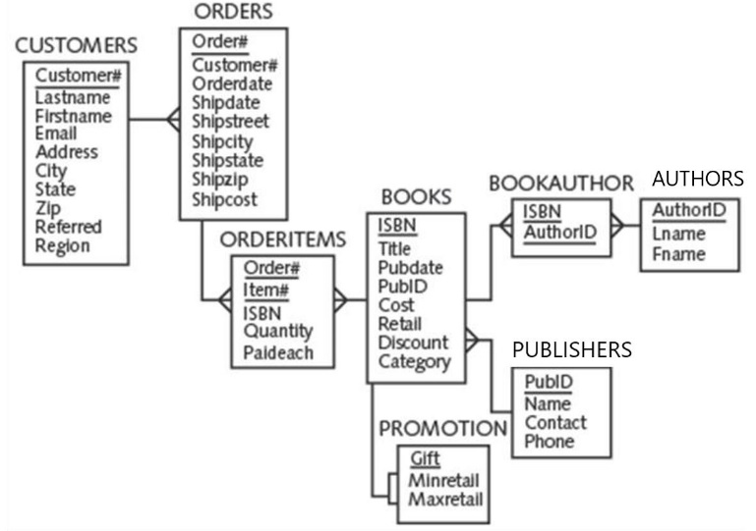

Produce a list of those customers who live in the state of **Florida** or **Texas** and have ordered **computer books** that has **an ISBN starting with '88'**. Display only those orders that **have been shipped**. Sort the results in **descending order of customer#**.

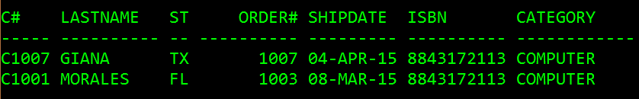

**Four SQL statements are required** by using the (1) implicit join, (2) explicit NATURAL JOIN, (3) explicit JOIN … USING, and (4) explicit JOIN … ON methods.

1. **Implicit Join (7 points)**

**SELECT c.customer# C#, Lastname, state ST, shipdate, b.ISBN, category**

**FROM customers c, orders o, orderitems oi, books b**

**WHERE c.customer# = o.customer#**

**AND o.order# =oi.order#**

**AND oi.ISBN = b.ISBN**

**AND Lastname IN('GIANA','MORALES')**

**AND category IN('COMPUTER')**

**AND b.ISBN IN ('8843172113')**

**AND shipdate IS NOT NULL;**

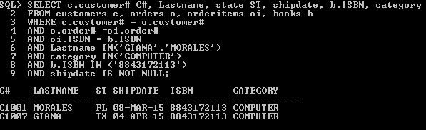

1. **NATURAL JOIN (7 points)**

**SELECT customer# C#, Lastname, state ST, shipdate,ISBN, category**

**FROM customers NATURAL JOIN orders**

**orders NATURAL JOIN orderitems**

**orderitems NATURAL JOIN books**

**WHERE Lastname IN('GIANA','MORALES')**

**AND category IN('COMPUTER')**

**AND ISBN IN ('8843172113')**

**AND shipdate IS NOT NULL;**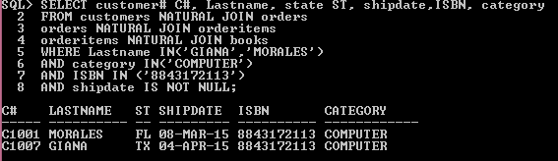

1. **JOIN … USING (7 points)**

**SELECT customer# C#, Lastname, state ST, shipdate, ISBN, category**

**FROM customers JOIN orders USING(customer#)**

**JOIN orderitems USING(order#)**

**JOIN books USING (ISBN)**

**WHERE Lastname IN('GIANA','MORALES')**

**AND category IN('COMPUTER')**

**AND ISBN IN ('8843172113')**

**AND shipdate IS NOT NULL;**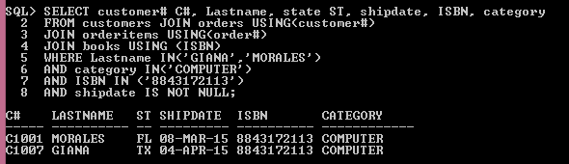

1. **JOIN … ON** **(7 points)**

**SELECT c.customer# C#, Lastname, state ST, shipdate, b.ISBN, category**

**FROM customers c JOIN orders o ON c.customer# = o.customer#**

**JOIN orderitems oi ON o.order# =oi.order#**

**JOIN books b ON oi.ISBN = b.ISBN**

**WHERE Lastname IN('GIANA','MORALES')**

**AND category IN('COMPUTER')**

**AND b.ISBN IN ('8843172113')**

**AND shipdate IS NOT NULL;**